22.35:
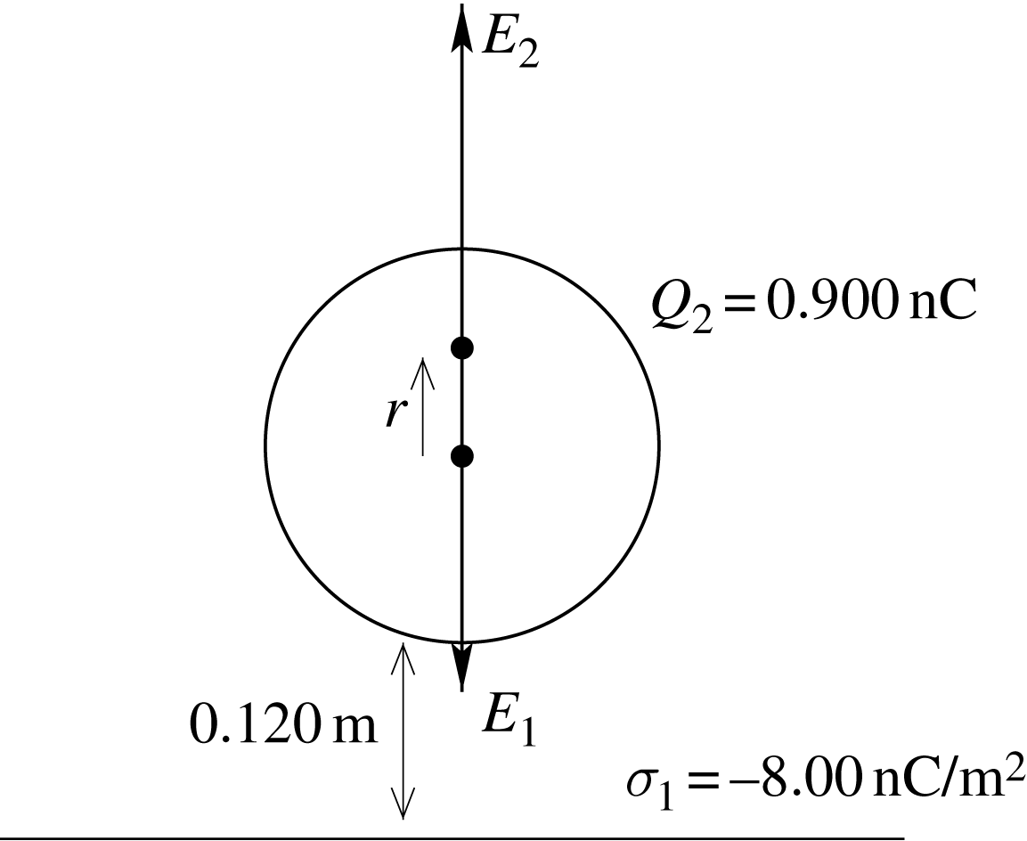

The electric field 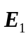 of the sheet of charge is toward the sheet, so the electric field 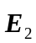 of the sphere must be away from the sheet. This is true above the center of the sphere. Let r be the distance above the center of the sphere for the point where the electric field is zero.
